**Senate Bill Voting Patterns 2018-2020 Predictions**

Model that obtains the probability of Trump getting his way in the 2018-2020 Senate

Marcos Aguilar  
Jonathan Taylor

**Introduction:**

On January 31st, in an article titled “Impeachment Briefing: Senate Votes to Block Witnesses” Noah Weildand of the *New York Times* reports on the subject of the impeachment trail. He reports that, “The Senate [voted Friday evening](https://archive.fo/o/kQvXD/https:/www.nytimes.com/2020/01/31/us/politics/trump-impeachment-trial.html) to block consideration of new witnesses and evidence in the impeachment trial, all but securing President Trump’s acquittal.”[1] This indicates that Trump due to having a friendly republican led senate was able to get his way within the Senate and is now another step closer to ending the impeachment in which negatively impacts him. However it is not as if he made it off easily as the Times reported, “The motion failed 49 to 51, with Senators Susan Collins and Mitt Romney joining all 47 Democrats.”[2] Accordingly, President Trump was able to get his way within the senate, but it was a vote in which came down and was much closer than one would think.

This is not a pattern in which is unusual and in fact patrician lines falling along with the president is something not uncommon. Grover and William argue in fact that “modern concept of the president as party leader emerged during the late nineteenth century.”[3] This means that for quite some time the US president’s influence on legislation passing or failing is very often a reflection of partisanship. This pattern has held true in all but a few cases within modern history, but generally speaking remains a staple of US politics that if a president supports a bill, then it is a bill supported by the party of the standing president. Thus, today Trump stands succeeding such a historical pattern, with Trump’s say within politics influencing that of his party and setting a tone for what bills the republican party will support and what bills the democratic party will rally against.

Today such a mentality leads many people into a stigma considering the outcomes of congress as a win or a loss dependent only upon how the overall composition of the congress. However, this is not entirely true. Given that many consider the voting patterns of congress men to be informed very much by “Constituents and contributors”[4] rather then simply based on patrician voting would indicate that often times one ends in a situation where what should be a safe vote becomes close. Thus, it is not safe to assume the conventional wisdom that whatever Trump desires will be passed in the US senate. This then begs the question, how often will 2018-2020 senate vote in line with Trump bills?

**Purpose of model:**

The focus of this project is to analyze how likely it will be for the 2018-2020 Senate, including the new senators elected under Midterm Elections on Nov. 6th 2018, to vote in line with President Donald Trump. The 2016-2018 Congressional Secession was when the Republican party had control of the Congress most Trump was getting his way often in the legislature. However, after Midterm Elections, when the Democratic party took control of the House of Representatives, most would expect for Trump to rarely get his way in congress. On the other hand, after midterm elections, most of the Senate remains in control of the Republican party, which may mean that Trump will continue to get what he wants in at least one branch of the legislature. So, one needs to subsequently answer the following question: how often will the current Senate vote in line with what Trump wants?

**Data and methodology:**

With the use of the data in “Tracking Congress in the Age of Trump” by *FiveThirtyEight[5]*, the development of a model to predict whether the Senate will pass or fail to pass a random bill in line with Trump’s position was created. This data includes a “Trump Score” for each senator, the percentage of times that each senator has voted on bills in line with Trump’s position. In the model, the Trump Scores are used as the probability of each senator voting on bills in line with Trump. Each senator’s Trump Score was obtained by *FiveThirtyEight* by adding the number of times the senator voted “yes” on a policy supported by Trump and the number of times the senator voted “no” on a policy opposed by Trump, and then dividing this sum by the total number of bills the senator voted on for which Trump’s position is known. Trump’s position was considered to be known when either him or someone on his behalf clearly expressed support or opposition on the bill. The article analyzed 79 separate bills to obtain 105 different Trump Scores. The data obtained from *FIveThirtyEight* included 9 former senators that are no longer a part of the Senate. In order to answer the main question focused in this project, and focus on the current Senate, the data for these former senators was disregarded. This data is the core of the model and helped us predict how often will Trump get his way in the Senate.

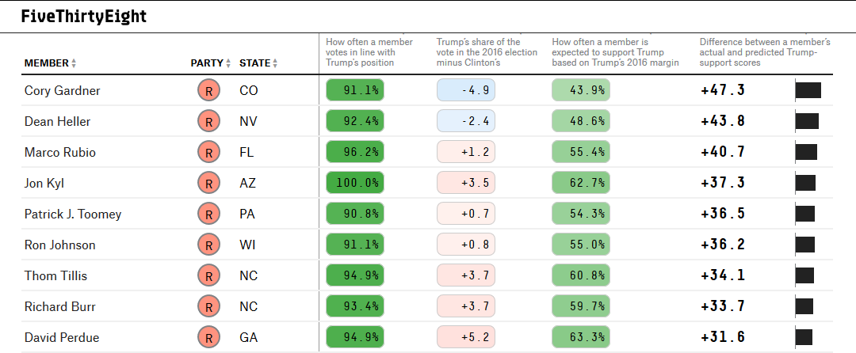

**Figure 1**

The article from *FIveThirtyEight* also included the vote of each senator in each of the 79 bills in which Trump’s position was known. This specific data was used to obtain each senator’s voting pattern in line with Trump under the 79 different bills. To obtain this voting pattern the compared every senator’s vote against Trump’s position under each bill. This individual voting pattern per senator was then used to obtain the correlation between one and all other senator’s voting pattern. This can be seen in figure 2 and will be further discussed in the analysis of the model.

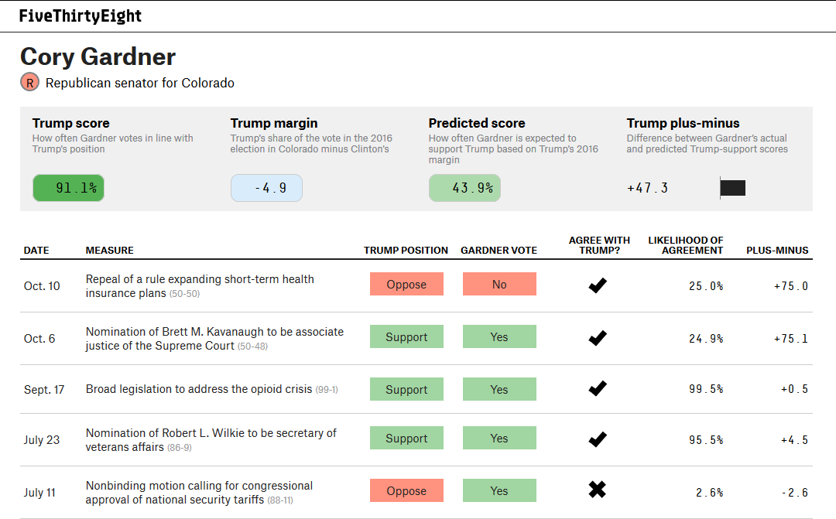

**Figure 2**

The data found in this article didn’t include the nine new senators that were elected on Midterm Elections. For the purpose of the research question, these newly elected senators were added to the model. Accordingly, these new senators had no voting patterns in the bills analyzed by *FIveThirtyEight*.In order to include these new senators in the model, different correlation coefficients and a Trump Score were assigned to each of them based on their political party, previous voting or veto, and campaign speeches. A quartile distribution of possible Trump Scores was assign as a measure for the uncertainty. The values of the moderate, average, and partisan were assigned to each senator in a percentile, with each value having a percentage and Trump score based on the average democratic and raised or lowered a quartile within the standard deviation from the mean. 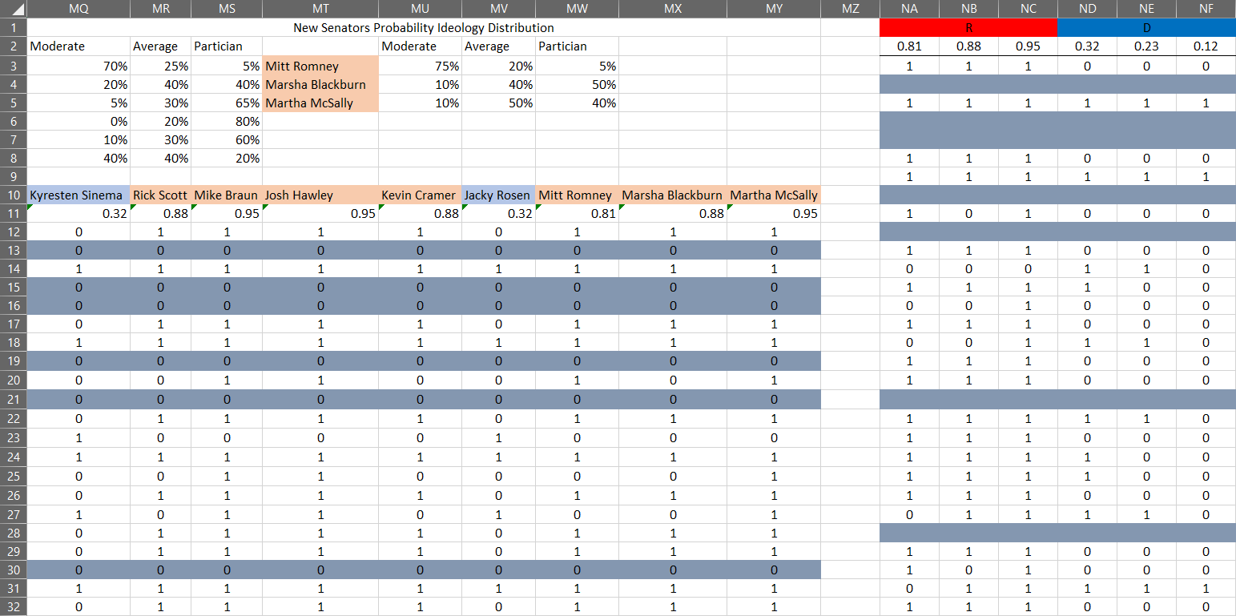

**Figure 3**

**Model:**

With the data previously described, a table was created showing each senator’s voting pattern under each piece of legislation which can be seen in figure 4. This table was then turned into a simpler table containing only with 1s and 0s under each of the 100 senator’s columns against each of the 79 passed legislation. Subsequently all non-bills were removed and the Trump score re-calculated. A vote in line with Trump was assigned a 1 and a vote against Trump’s position was assigned a 0. This can be seen in figure 5. Then using this table of 1s and 0s a third table, a 100x100 correlation matrix was created with the formula: =mcorrels(B85:CW163). This correlation matrix would indicate how much each sentor’s voting patterns would correlate with one another. This means that if one senator was to vote one way, how likely is it that another senator would vote that same way. This matrix provides the voting correlation of each senator against all others considering their voting pattern based on all 48 bills. This table can be seen in figure 6.

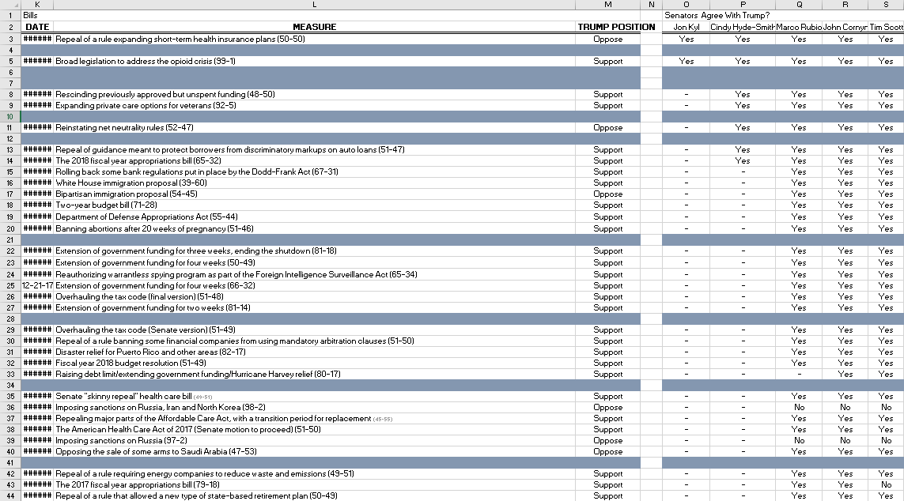

**Figure 4**

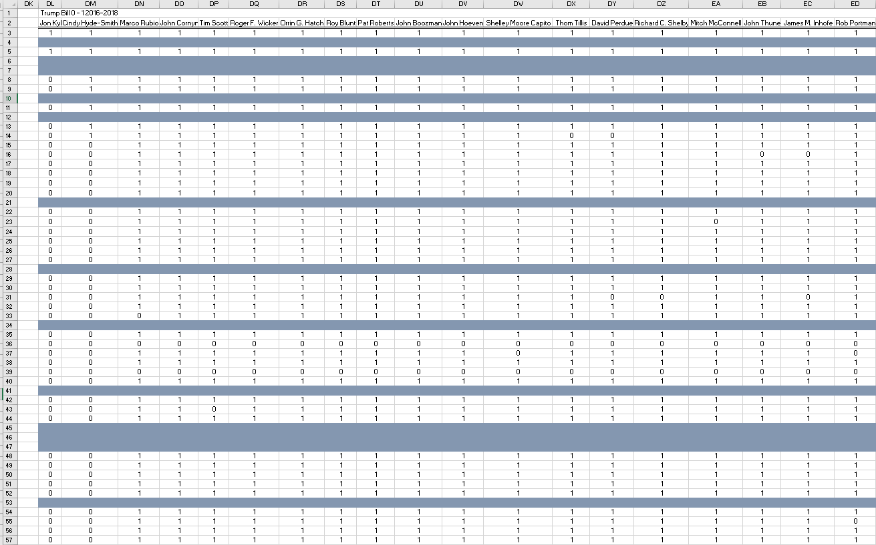

**Figure 5**

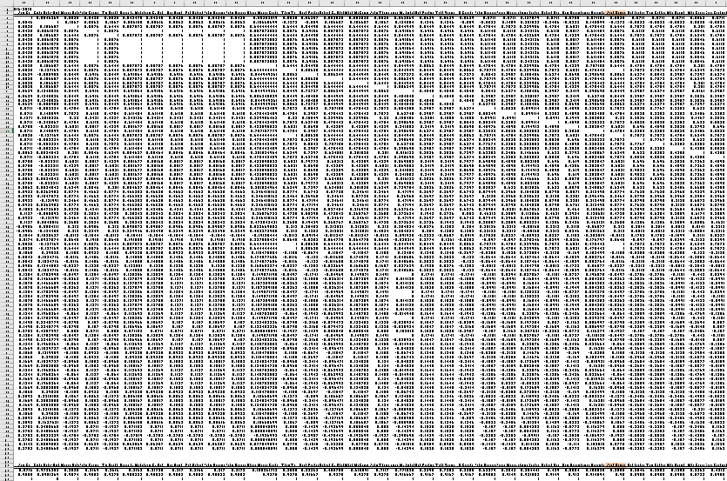  
**Figure 6**

Using the correlation matrix, a random value, which takes into account the 100 correlation coefficients, for each senator (100 CORRANDs) is then obtained with the formula: =corand(B167:CW266). These CORRANDs, correlated but randomly generated variables, are then compared against each senator’s Trump Score to answer whether a specific senate votes on line with Trump or not. If the Trump Score of the senator is higher than the CORRAND obtained than the model outputs a 1, and, if lower, then it outputs a 0. This was done by using an if statement formula =if(Trump score > corand, 1, 0). A 1 means that the senator votes in line with Trump and a 0 means the senator votes against Trump’s position. These positions per senator change as one recalculates the random variables given their connection to the CORRANDs. This process can be seen in Figure 7.

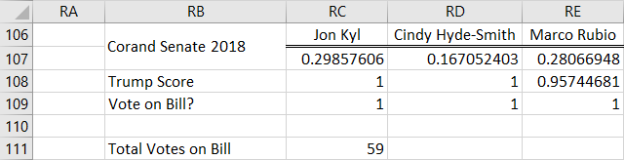

**Figure 7**

To simulate this model the total number of random votes in line with Trump was obtained through a simple sum formula, which adds up the 100 random votes of all senators. A sum equal or above 50 means that half or more of the Senate votes in line with Trump, which also means that Trump gets his way in the Senate with a simple majority vote. This total Senate vote is then simulated 10,000 times using a simulation table. Finally, the probability of Trump bills passing is obtained through =1-percentrank.in(10,00sims,50) formula that counts only the scenarios in which the total number of votes is equal to 50 or above (Trump gets his way in the Senate.)

The second part of the model involves the nine new senators elected and the nine former senators who will be replaced. This is done in a similar process, except by removing the nine senators who retired in 2018, and by adding the new senators. The senators removed were, Senators: Jon Kyl, Orrin Hatch, Bob Corker, Jeff Flake, Bill Nelson, Joe Donnelly, Claire McCaskill, Heidi Heitkamp, and Dean Heller. Those added were Senators: Martha McSally, Marsha Blackburn, Mitt Romney, Jacky Rosen, Kevin Cramer, Josh Hawley, Mike Braun, Rick Scott, and Kyresten Sinema. These new senators probable Trump scores were estimated by finding the average Trump score for both democrats and republicans. The standard deviation for democratic and republican senators was then found. With this data obtained 3 different probable Trump scores were created for democrats and republican’s dependent on if the senator was moderate (R 81% or D 32%), average, (R 88% or D23%), or partisan (R 95%, D11%.) Then for each senator, a probability was given to how likely it would be that they’d be moderate, average, or partisan. All these values would then be entered a discrinv Along with these nine Trump scores, nine voting patterns would be taken from the previous Senate based on which voting patterns were closes to the quartiel probabilities. The function ={ifs(Trump score D1= discrinv function, voting pattern D1, Trump score D2…, voting pattern D3)} would then give every new senator a probable voting pattern. This can all be seen in figure 8. 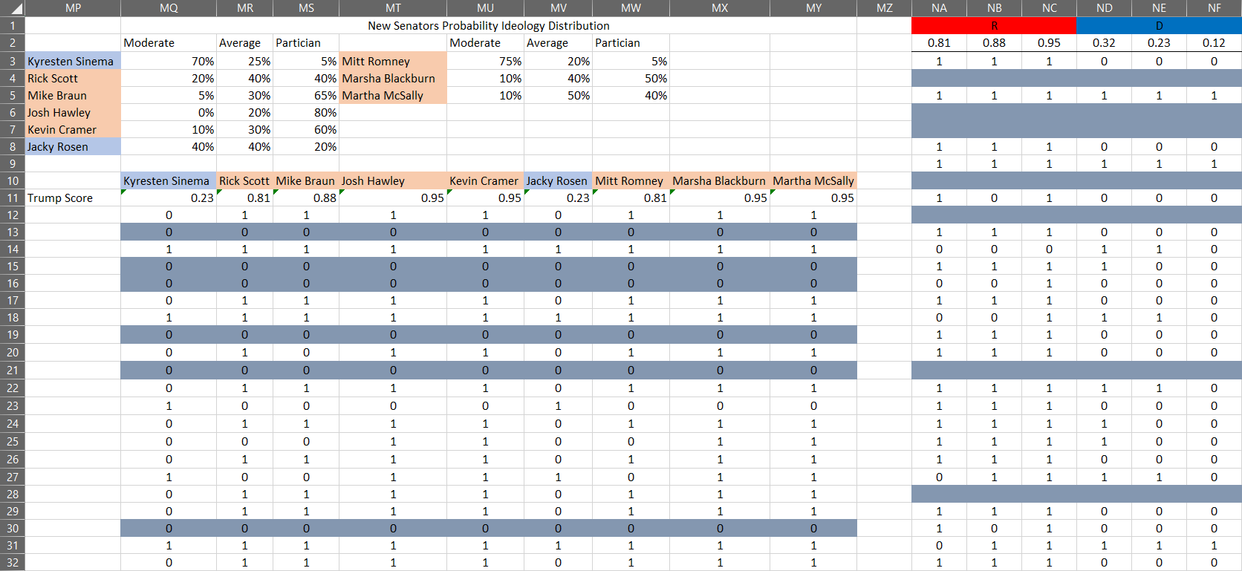

**Figure 8**

This would then be inputted into a copy of the previous senate patterns adding the new senators in where the old ones had been removed. With this another mcorrels function was created and used to make a corand array. This would then be compared to the new and old Trump scores in the Senate and totaled to find the number of votes. With this function a monte carlo distribution with 10,000 trials would be run to find 10,000 different possible outcomes under this model. Similarly, a function =1-percentrank.in(10,00sims,50) would be used to find the new probability Trump would get his way in senate bills.

Furthermore, the data obtained may have some issues. There were two evident issues with the model, which were the type of legislation passed in the Senate, and the 2 Senators Jon Kyl, and Cindy Hyde-Smith who had both voted little in the 2016-2018 terms making their Trump scores at 100% due to lack of data. There were methods implemented to limit the amount of error in which both issues would cause to the model.

First, the senate has two jobs, to pass bills, and two nominate federal officials. Of these two jobs passing bills tends to be the more significant of the two, with it also being the more polarizing of the two. Senate appointments on the other hand tend to be less polarizing. Thus, to narrow the scope of the data, it has been chosen that the research question will only pertain to legislation and thus voting on bills. Because of this, all appointments have been removed from the data, and the Trump score adjusted to only pertain to bills.

Secondly the Trump score would also be moved right due to Senators Jon Kyl, and Cindy Hyde-Smith small record on voting. To best adjust for their potential voting patterns a formula was devised to estimate the uncertainty of their voting records. This formula was, ((1+number of times hasn’t voted)/ (total votes+1))/4 This percentile for both Jon Kyl, and Cindy Hyde-Smith would be multiplied by rand() and subtracted from both their Trump score to account for their uncertain actions due to the low amount of data on both Senators.

**Results:**

For the previous Senate that does not consider the newly elected senators, the results obtained were as follows. The probability of Trump getting his way in Senate bills was 72% in the 2016-2018 Senate. Given the high Trump Score of most of the republicans controlling the Senate, it makes sense that 72% of the time there will be at least 50 or more votes going in line with Trump’s position. The cumulative distribution can be seen in figure 9. This is the distribution of senate votes on the y axis with the percent chance on the x axis. This graph thus aids one in seeing what it means for the average implementation of a senate bill in which Trump support by observing where the line in the graph intercepts the 50 line on the y axis. One can be seen in figure 10 the probability distribution of the number of votes in line with Trump. This graph indicates the chance for every probability distribution to take place. With the y axis indicating the likelihood in percent of any given vote taking place and the x axis indicating the number of votes in which a bill that Trump supports receives. As one can see it is approximately normal but looking a bit skewed to the right. The average number of votes in line with Trump is around 56, so, on average, 56 senators will vote in line with Trump’s position.

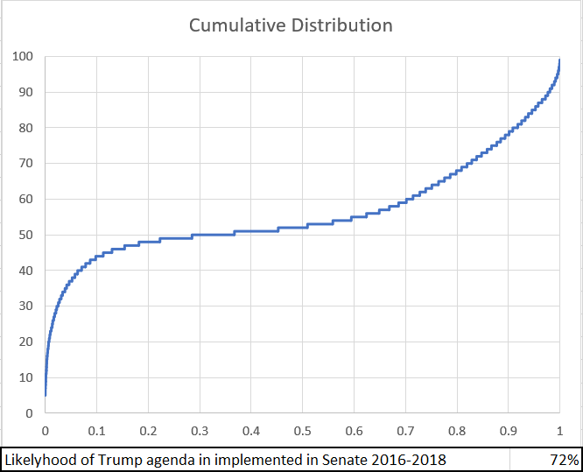

**Figure 9**

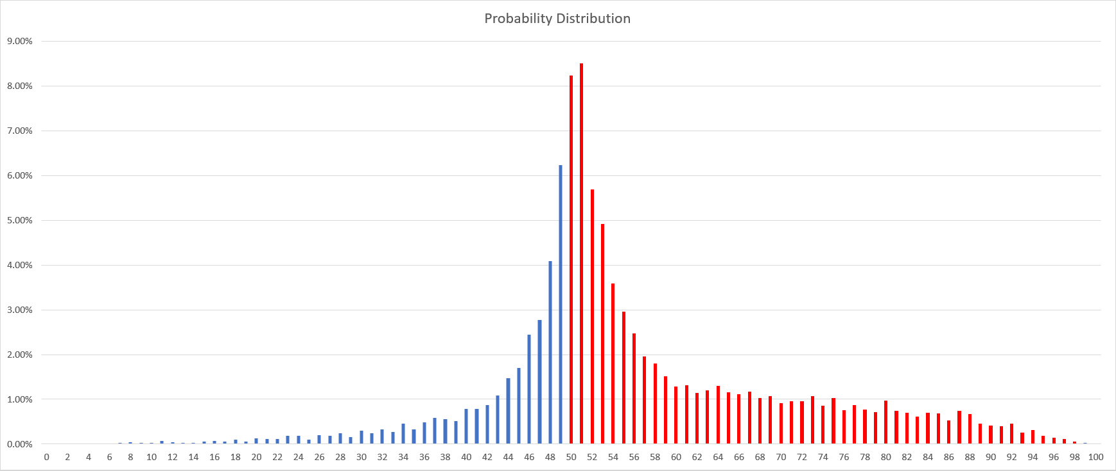

**Figure 10**

For the new Senate formed with the newly elected senators, the results obtained were as follows. The probability of Trump getting his way in Senate bills is 81% in the 2018 Senate. This is a nine percent increase since the 2016-2018 senate. This makes sense considering the two seats gained by the democrats were in swing states, where it is more likely the new Senators Kyresten Sinema from Arizona and Jacky Rosen from Nevada will have to vote with more caution to maintain their seats. This is opposed to the seven new seats held or gained by the republicans which have mostly been in much more red states allowing them a greater degree of freedom. The cumulative distribution of votes in the senate for Trump legislation can be seen in figure 11, which indicates that most of the time the senate will vote with Trump, and few times will it not, and those few times will be on issues in which a large majority of the senate disagrees with the President on. Figure 12 shows the probability distribution of votes for senate legislation in line with Trump. As can be seen the graph also is right leaning but looks normal otherwise. Lastly, on average it is expected that 57 senators will vote in line with Trump. This works perfectly with the previous 2016-2018 data considering that 56 was the average for the 2016-2018 data. This increase works perfectly considering that with an additional one seat increase in the senate to the republicans would cause the average for to move over by one in implementing Trump legislation.

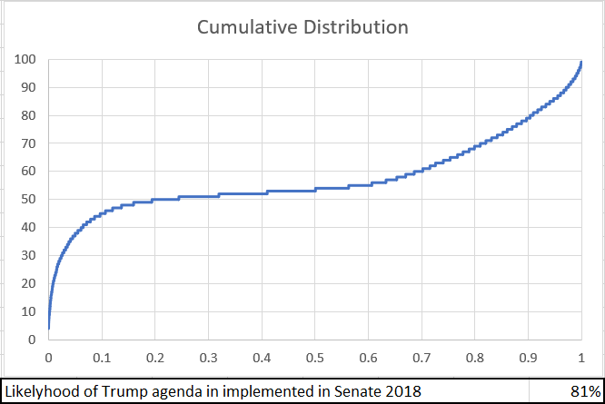

**Figure 11**

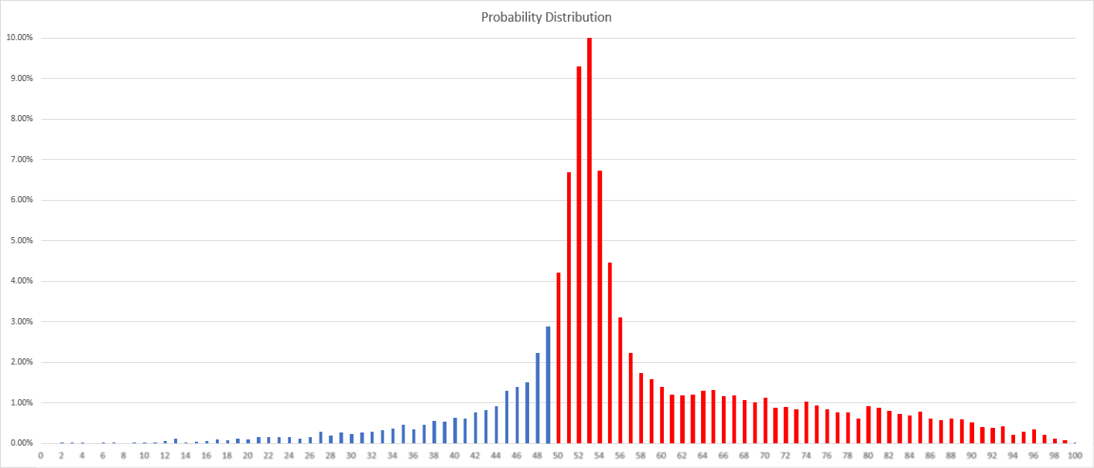

**Figure 12**

**Conclusion:**

The model created works to answer the preliminary research question. The results obtained show that given the current Senate with the Republican party controlling the majority of it, President Donald Trump is very likely to obtain his way. The current Senate is likely to vote in line with Trump’s position on different bills, around 81% of the time. This ranges from the closer resulting features of obtaining his policy objectives with more narrow votes and obtaining his way easily with less narrow votes. This model however does not make distinctions between cross party bills or much more non patrician bill with bills that are more patrician in nature.

The data obtained may be molded to answer further questions. The model may go beyond and may work to analyze the Senate’s correlation of voting patterns under different policies, showing different correlations as one considers the specific policies involve. While this wasn’t the focus for the model, this model could work to analyze more different variables and uncertainties regarding the Senate. An example considered, is the model being further developed to analyze the probability of Trump getting his way in the Congress given that the specific data was obtained for the House of Representatives. This would require further research and would be a much larger project. Overall the model was successful in answering the focused question and lead to the genuine interest of further research to answer more specific questions and further develop predictive models based on the uncertainty of passing bills that do or do not align with Trump’s end policy goals within the Senate.

1. Weiland, Noah. “Impeachment Briefing: Senate Votes to Block Witnesses.” *New York Times*, January 31, 2020.
2. Ibid
3. Cleveland, Grover, and William McKinley. “Emergence of the President as Party Leader.” *Presidential Studies Quarterly* 35, no. 4 (November 2, 2005).
4. Kau, Maes B., Donald Keenan, and Paul H. Rubin. “A General Equilibrium Model of Congressional Voting .” *The Quarterly Journal of Economics* 97, no. 2 (May 1, 1982): 271–93.
5. Bycoffe, Aaron. “Tracking Congress In The Age Of Trump.” FiveThirtyEight, November 20, 2018.